Intraorganizational Electronic Commerce
Electronic commerce cannot reach its full potential as a stand-alone concept addressing mainly customer-organization, intraorganizational, or disconnected internal automation activities. For companies to be fully effective, these three activities must be integrated and the corresponding software applications developed together.
The technologies and methods associated with electronic commerce are already used extensively within firms, where the focus is on operations and other aspects of efficiency-gaining activities. These activities are known by various names : enterprise integration, process control systems, business process reengineering, and work-flow management.
Internal commerce is the application of electronic commerce to processes or operations. Specifically, we define internal commerce as using methods and pertinent technologies for supporting internal business processes between individuals, departments, and collaborating organizations.
Private commerce is significant because it is closely related to market orientation toward creating superior value for customers. This requires that a company understands a customer's business value chain and tailor its operations, products, or services to deliver better value. A company can create customer value at any point in the chain by being more efficient in its operations, delivering better quality, and being flexible.
To achieve better performance, a business must develop and sustain competitive advantage. Competitive advantage was once based on structural characteristics such as market power, economies of scale, or a broad product line.

Work-Flow Management
The use of work flows of task coordination is important because people do not work in isolation but collaborate to accomplish tasks. Companies have developed methods to optimize work flows by pruning unneeded operational steps and moving much of their internal paper handling onto computer networks.
The most common work flows are administrative - time-consuming, unexciting task such as processing a trip request from initiation, through approval, to issuing the ticket, cutting a check for the cash advance, and debiting an account.
These work flow reengineering efforts have been mostly localized to a few departments or tasks. Extending this effort to coordinating enterprise processes using electronic commerce methods is the logical next step for most organizations. If the usefulness of work flow automation is granted, the next step is to use technology to improve it.

Product or Service Customization
Customization is often associated with agile manufacturing. Since the early 1980s, concern about global competitiveness has popularized the terms world-class manufacturing, lean production, and agile manufacturing. These terms connote essentially the same things : elimination of inventory and other forms of "waste", greater flexibility in production scheduling, shortened lead times, and advanced levels of quality in both products and customer service.
Customization focuses on two issues :
- time-to-market and
- flexible operations
Time-to-market depends largely on gathering the specific consumer preferences and using these preferences to custom design products or services. Custom designing any product or service requires tremendous coordination between various departments and functions.
Flexible operations depend largely on implementation details or working practices that make time-to-marketing a reality. A company convinced of the value of being just-in-time triggers production automatically on customer orders, rather than stockpiling inventory.
Supply Chain Management
A supply chain is the network of suppliers and customers within which any business operates. For example, a computer manufacturer has a chain of suppliers for its microprocessors, disk drives, video monitors, power supplies, systems software supplies, and so on, and a chain of customers in its retailers, resellers, and ultimate consumers.
Supply chain management is important as it is becoming impossible for companies to compete at the business or industrial level as isolated entities.
SCM is important in retailing because it helps manage the demand and supply functions. It is safe to say that many manufacturers have not reached well to innovations in the distribution chain, where consolidation has shifted power to the hands of big supermarket chains and discount stores, as well as a few mega-wholesalers.
Supply chain management has the following characteristics:
1) An ability to source raw material or finished goods from anywhere in the world.
- A centralized, global business and management strategy with flawless local execution.
- On-line, real-time distributed information processing to the desktop, providing total supply chain information visibility.
- The ability to manage information not only within a company but across industries and enterprises.

Internal Commerce
Macro forces that affect organizations can be used to make business suitable for internal commerce. Effects of macro forces includes reduction in the functionality of middle management, increase in global market place competition, changing wants and prejudices of various customer and reduction in expenses.
These affects resulted in countless strategies for management in order to perform efficient operation like:
- Total quality management
- Business process improvement
- Business process reengineering

The goals of business process improvement and business process reengineering is to increase productivity, reducing cost and enhancing its quality and service. Process improvement is based on 80-20 rule. Where 20% of the work flow consumes 80%°of the effort. Process reengineering objective is to create new process for making changes to existing process.
Global Markets
Global economy is in demand because of the widely spreaded technologies related to, communication. Because of this economy, global markets have been emerged for standardizing consumer products. Global market can be defined as performing business in home country as well as a part or business in foreign country.
Global market differs from international market. The former crosses the functions of autonomous and decentralized organization where as the latter has an enterprise in a foreign country.
Global market has emerged because of dissemination associated with advanced technologies which improves the speed of access as well as provide efficient information technology. Due to this all the functions related to finance can flow easily in an organization once they are approved by national government.
Global market are generally preferred by MNC's in order to attain globalization. MNC's that are emerging are employing global market to overcome the following issues:
- High economic consolidation
- High saturation and maturity
- High labour and production cost

Global market in MNC are different from the way represented in small organization which is responsible for solving distribution issues related to global sourcing, meeting the requirements of potential customers. There are many in an organization. The critical issue that must be initially solved is to decide about the organizational structure that should be used for global market.
Organization can be viewed as a collection of both vertical and horizontal business departments.
The Vertical Organization
The two problems that are present in vertical organization structure are :-
1) It creates boundaries that discourage employees in different departments from interacting with one another.
2) Departmental goals are typically set in a way that could cause friction among departments.
The reasons for lack of interaction between employees of different departments is because of the gap that exist between them, due to which there is no proper communication media that makes the interaction possible among them. In vertical structure, department are arranged in a hierarchy manner specifying that as the hierarchy moves to the lower level, the gap between them increases. Gaps are dependent on geographic widespread and growth of company.
It is very time consuming and requires more resources for storing issues that originates while understanding the different process of business at lower level.
Lack of interaction results in misunderstanding, confusion among different functional departments. The three important things that are not present in vertical structure are :
i) Product
ii) Process
iii) Customer
In the absence of these components, it is very difficult for a higher level management to effectively run his business.
Horizontal Organizational Structure
In horizontal organization, a two-layered structure is constructed that replaces the multilayer architecture of vertical organization. One layer consist senior management group who are responsible for making strategic decisions and setting the goals and objectives for an organization. Second layer consist of workers that forms the team process.
The aim of horizontal structure is to
- Improve the management flow
- Improve the quality of work
- Increase the value for customers.

Horizontal structure is responsible for
- Aligning the needs of a market, strategies of the corporate offices and the processes that are crucial for an organization.
- To eliminate, what is unwanted, unnecessary, and also assures that the value is increased by process depending on customer's approach.

Implementing these objectives however is very difficult because of different views from each member pf a group. In horizontal organization, processing of information is done at lower-level by process team who can solve the issue fastly, Because of the facility, company can operate with greater flexibility in the present changing business environment.
If the objectives of horizontal structure are implements successfully, this result in,
- Increased communication between the workers of different departments.
- Better understanding of the responsibility of other workers belonging to different departments.
- Reduces the frictions that are expensive which are raised due to misunderstanding and confusion.
- Eliminating the need of the resources that are required for vertical communication.
This structure is created to overcome the problems that were present in vertical organization. The main objective of this structure is to allow the product and services to flow freely from one functional department to another. This is possible by enhancing the communication and avoiding the execution of irrelevant tasks. In order to effectively run a business it is very important for the business management to understand different processes of business.
New Forms of Organizational Structure
The two new forms of organizational structure are becoming prominent:
- virtual or network structures
- brokerage structures

1. Virtual or Network Organizational Structure '
Virtual organization is a firm whose majority of activities are outsourced. Virtual organization, otherwise called virtual corporation!; as defined by recent business week survey states that it is temporary network of independent companies where suppliers, customers and even rivals linked by information technology to share skills, costs and can access other market. It will neither have a central office nor an organization chart. It will have no hierarchy, no vertical integration.

Element of Virtual Organization
The following are the elements of virtual organization:
1) Technology- Partnerships, contracts, transfer of information are done through the usage of technology. Also its application reduces the legal issues and speed up the organizational activities.
2) Opportunism - The work of virtual organization is based mostly on opportunities. The companies unite together to seek an opportunity and then go apart leading to informal and partnerships among them.
- Excellent output-As every company put its core competence in achieving the target, the output tends to be excellent like best-of-everything.

- Trust - The main attribute that binds the companies in a virtual organization is trust.
- Boundary less - With an aim of producing an excellent output companies work beyond their boundaries.

The various names that can be used to refer virtual corporation are network organization, hybrid arrangements, organic network, value-adding partnerships using the concept of virtual organization it is possible for a company to achieve better efficiency and perception in the competitive world. Cisco system is an example of virtual corporation that implements the principle of virtuality.

Understanding the Structure of Virtual Enterprises
Two major approaches are used to form virtual organizations:
- Downward approach and
- Lateral approach

1) Downward Approach - This approach is originated by large organizations that uses vertical structure for reducing their overhead resulting from outsourcing. The two main purposes of outsourcing are:
- to reduce costs associated with fixed assets and
- to maintain a focus on key operations.
Outsourcing breaks down the company's vertical structure; for instance, a manufacturer once making all crucial parts now establishes a network of suppliers to provide needed parts. A company that successfully outsources becomes economically slimmer and more adaptive.

2) Lateral Approach - This type of approach is observed in small, specialized firms
that, in the interest of seeking strategic alliances, form partnerships along a value-added chain (e.g., suppliers, manufacturers, and distributors).

Without acquiring the ownership headaches, the core firm of such a network can increase profits and reduce risks. Each such core firm can benefit by modeling the adaptively and responsiveness of a small, specialized company and the scale economies of a large and integrated firm.
Electronic Organizations and Brokerages
The goal of electronic brokerages is to increase the efficiency of the internal marketplace. Internal markets are beginning to appear not only in corporations but even in non business institutions like the government. They are created in side organizations, allowing firms, suppliers, and government agencies to meet the new challenges of a fast-changing environment.
Internal markets aided by computing will be replacing the organization structure of the past: Vertically and horizontally integrated organizations. The change over to internal markets is difficult even with the best planning, yet more organizations are moving in this direction because economic realities demand it. Corporations must master an intensely competitive global economy that requires massive technical and management innovation. These corporations, however, require a clear organizational structure to manage these work flows and the agents (or brokers) carrying out the work flow in the virtual organization.
Our working definition of an electronic brokerage is : multiple services provided by a single interface with a single point of accountability on an order-by-order basis. Brokerage service providers are intimately involved in the details customer operations and to end, in order to understand customer needs and deliver better services.
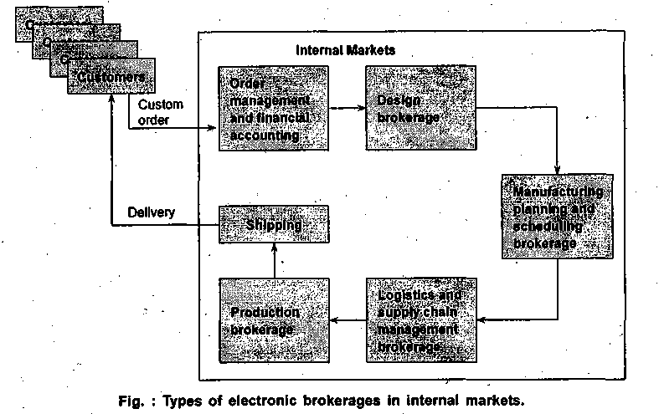

In production and operations management (POM), we see the appearance of internal brokers for customer order management and for logistics and supply chain management. Figure below depicts arid organization structured as an internal market-place around the concept of brokerages. The focus of this internal market is to process a custom order as fast as possible and deliver it. The issues related to customization requires that the firm be organized as a collection of electronic brokerages that coordinate among themselves to provide the best service to the customer.

Workflow Automation
Workflow automation can be defined as a process of performing automation on regular business tasks. The objective of workflow automation is to provide a way for making decision that is effective in terms of cost and time.
Workflow describes the way in which information moves from one business process to another operations required for information processing are identified. It also describes the way in which tasks are distributed among workers. In short, work flow can be defined as the movement of information from one user process to another. A process is created when all workflow are merged together.
Workflow can be divided into several tasks which are then assigned priority to decide which task is to be executed first. Work flow can be of two types :
- Simple workflow - Simple work flows typically involve one or two tasks, for example, an intelligent mail application helps prioritize and route a user's mail.
- Complex workflow - A complex work flow may involve several other work flows, some of which may execute simultaneously.

Workflow can be defined as a method of determining amount of activity related to cross functional area. Earlier all business operations were performed independently. But now, a new model is created using the existing model that treats the business function as extended enterprise. If the reengineering is performed successfully, its results include
- improved customer relationship
- increasing leverage in the marketplace
- reduced costs and inventories, and
- faster and more reliable deliveries of material and services.

Organizational integration is extremely complex and typically involves three steps:
1) improving existing processes by utilizing technology where appropriate,
2) integrating across the business functions after identifying the information needs for each process,
3) integrating business functions, application program interfaces, and databases across departments and groups.
Work flow Coordination
In order to efficiently perform the market related business processes it is very much essential for all the tasks and resources to coordinate with each other. This coordination helps in creating customer value. A horizontal structure between different functional departments is adopted so that the business process can be performed fastly and easily which was very difficult using vertical structure approach.
Examples of tools used for work flow coordination include, routing packages in electronic form such as Lotus Notes that provide network-based automated services Workflow coordination becomes difficult and harder to implement when more number of coordinating parties are involved. The solution to this problem is software agent that is used by many companies to have better workflow coordination.
Work-Flow-Related Technology
Pressures for more comprehensive work-flow systems are building rapidly. Most of the large organizations feel that middle-level management is required for performing better work flow. They are important because, they act as memory for organization, they have the idea of how things must be completed, they provides a means for coordinating. However it is assumed that work flow tools can act as a substitute for middle manager.
Work flow is nothing but unstructured content that is very hard to find because it keeps on shifting. It will produce results if importance is given to realities that are existing in today's world.
Work flow in an unstructured context remains elusive, and the notion of comprehensive work-flow systems must be regarded as nothing more than a dream. It is best to focus attention on today's realities and the actual market trends that show some promise. Among them are the following:
- Middleware is maturing - Users or third-party providers need to learn how to develop work-flow applications within the middleware environment. The most suitable example of middleware is Lotus Notes which is the popular groupware product. Work-flow applications built on the Internet or public domain tools remain elusive.
- Organizational memory is becoming practical - The new tools for organizational memory are advancing toward what can be called the "corporate digital library". These tools are based on the premise that information is not a finished product but something that can be refined in new ways that are useful to different people at different stages in the work process.

Customization and Internal Commerce
Technology is transforming consumer choices, which in turn transform the dynamics of the marketplace and organizations themselves. Technology embodies adaptability, programmability, flexibility, and other qualities so essential for customizations. Together they have created the promise of "any things, any way, any time". Customers can have their own version of virtually any product, including one that appeals to masses rather than individuality if they so desire.
All markets are not well suited for the application of the customization principles. Customers of really innovative products representing engineering breakthroughs (wireless technology) do not (yet) demand distinctive features because they have no idea what the product is all about.
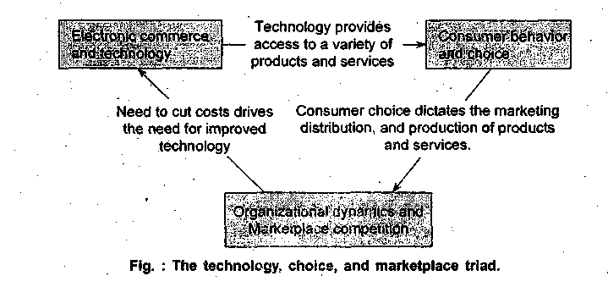
Today technology is so pervasive that it is virtually impossible to make clear distinctions among management, design of work, and technology in almost all forms of business and industry. Technology has moved into products, the workplace, and the market-place with astonishing speed and thoroughness. For this reason we need to re-examine customization through the technology lens.
Mass Customization
Mass production was replaced by mass customization. As mass production gives importance to cost reduction and increased productivity the different organizational structures are disappearing. This is the main reason of switching from mass production ;to mass customization. However, this requires a lot of flexibility as well as basic perception.
Customization need not be used only in the production of cars, planes, and other traditional products. Apart from producing traditional products, customization can be used in textile industry that is dependent on point-of-sale information. Because of customization, textile or clothing industry have gained a lot of profitability.
Technology is also enabling new forms of customized production in the apparel industry. Example of such technology is scanning the body using infrared rays by employing a-technique called infrared body scanner, where the measurement of customer is taken-using infrared rays that the transformed into digital information so as to be processed by -automated manufactured equipment. A direct interaction between producers and customers is also possible thereby avoiding retailers. This can be done by storing the desired information in a database.
Another technology is radio frequency tags, which would eliminate the need for bar-coded labels and thus significantly reduce the time shippers and retailers now spend inputting this information into computer-based inventory systems.
Customization of Services
Customization is also becoming important in service industries, where product differentiation holds the key for attracting and retaining customers. Unlike manufacturing firms, organizations that provide services (banks, retail outlets, hospitals), as opposed to manufacturing products, have unique characteristics that warrant special attention.
For example, service firms are more people-oriented and customers tend to participate actively in the service process. The operations function cannot be divorced from the marketing function, given that production and consumption occur simultaneously and that services cannot be inventoried. The resulting variations in demand present a challenge to the operations manager to use service capacity effectively.
Supply Chain Management (SCM)
There is a growing realization that product excellence does not guarantee competitive advantage and profits. Many firms have been seeking 3. way of increasing profits through better management of the supply chain (network of partnerships) using technology and avoiding the extremes of either internalizing it or of outsourcing most functions. In the interest of acquiring an edge, these companies are beginning to use the supply chain network to reduce costs and complement their products with basic and value-added services.
But supply chains need to be managed. Essentially, supply chain management (SCM) is an integrating process based on the flawless delivery of basic and customized services. Simply put, SCM optimizes information and product flows from the receipt of the order, to purchase of raw materials, to delivery an consumption of finished goods. SCM plays an important role in the management of processes that cut across functional and departmental boundaries. SCM goes beyond organizational boundaries, reaching out to suppliers and customers.
SCM is important in retailing because it helps manage the demand and supply functions. It is safe to say that many manufacturers have not reached well to innovations in the distribution chain, where consolidation has shifted power to the hands of big supermarket chains and discount stores, as well as a few mega-wholesalers.
In electronic commerce, supply chain management has the following characteristics :
- An ability to source raw material or finished goods from anywhere in the world.-
- A centralized, global business and management strategy with flawless local execution.
- On-line, real-time distributed information processing to the desktop, providing total supply chain information visibility.
- The ability to manage information not only within a company but across industries and enterprises.
- The seamless integration of all supply china processes and measurements, including third-party suppliers, information systems, cost accounting, standards, and measurement systems.
- The development and implementation of accounting models such as activity-based costing that link cost to performance are used as tools for cost reduction.
- A reconfiguration of the supply chain organization into high-performance teams going from the shop floor to senior management.
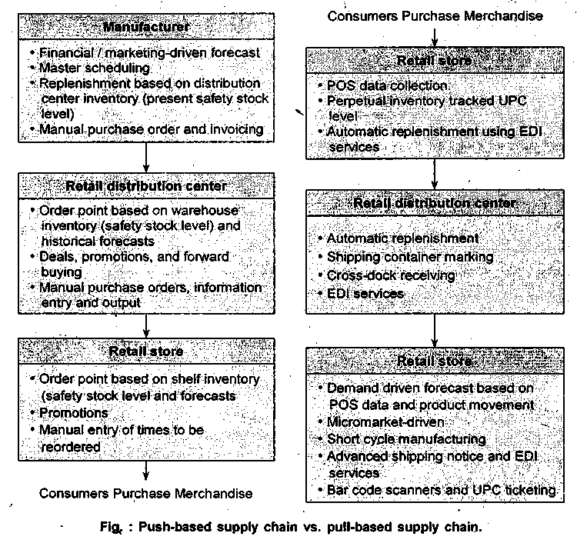

Figure above shows the two primary models of supply chain management: punch versus pull. These models contain three primary elements :

1. Logistics and distribution (integrated logistics): Logistics is a relatively new discipline that deals with the integration of materials management and physical distribution.
Although logistics and SCM are sometimes interchanged, think of SCM as an umbrella that incorporates the logistics function. Over the years areas such as materials management and distribution have evolved into logistics, which in turn has become one integral component of SCM.
- Integrated marketing and distribution: Most managers often do not realize that order processing and fulfillment processes may exceed 15 percent of the cost of sales. Traditionally, the customer order process is initiated by sales personnel, who have an in-depth understanding of the customers product and service requirements. In electronic commerce, the order process could be initiated by marketing information systems such as point-to-sale systems. Today, with the aid of technology, we are able to integrated the customer directly and react to changes in demand by modifying the supply chain.
- Agile manufacturing: Consumers and manufacturers are stressing quality and speed. One of the most influential visions of production goes by the name of agile manufacturing.

Efficient Customers Response (ECR)
The main purpose of efficient customer’s response is to improve the performance of retail industry. The benefit of using ECR is that it reduces the total cost by 10%. It does this by changing the way in which the products are purchased and concentrates on the continuous product replenishment (CPR).
ECR can be better understood by considering the data architecture that helps the front-office buyers, logistics personnel and executive managers to use transaction level data from POS system. When inventory is managed effectively, it results in minimizing the out stock and under stock and increases profitability.
With the help of ECR, front office buyers and inventory analyst can get the information related to product sales on-line which was a long process in the past.
In house system allows manager and buyers to perform the following three
responsibilities:
- They are responsible for analyzing the performance of standard products.
- To find upward trends and declines in the performance of trend, products on regular basis.
- Renew the product whose performance is decreased.
Apart from this it is also responsible for evaluating performance analysis and what if situations. It also repairs errors and ways to handle them.

Agile Manufacturing
Promotions must be closely tied to agile manufacturing capability. Agile manufacturing calls for flexibility and quick response to changing market conditions, customer demands, and competitor actions. In an ever-changing environment, people, processes, units, and technology reconfigure to give customers exactly what they want. Managers coordinate independent, capable individuals, and an efficient linkage system is crucial.
Agility implies breaking out the mass-production mold and producing highly customized products - when and where the customer wants them. In a product-line context, it amounts to striving for economies of scope - ideally serving ever-smaller niche markets, even quantities of one, without the high cost traditionally associated with customization - rather than economies of scale Also, agile manufacturing requires an enterprise wide view, where as lean production is typically associated only with the factory floor. Agility also embodies such concepts as rapid formation of multi company alliances to introduce new products to the market.
Agility is essential in a future that requires new and innovative manufacturing, practices, among them the following:
- Customers "custom design" products such as automobiles and clothing, electronically transmitting their requirements to remote locations capable of quickly manufacturing and distributing these products.
- Companies rapidly and easily form alliances to produce new products, employing advanced manufacturing concepts such as agile and virtual manufacturing.
- Small and medium-sized companies advertise their manufacturing capabilities over computer networks and efficiently bid on projects required by other companies.
- Software system brokers" connect users who heed temporary access to sophisticated manufacturing tools that would normally be too expensive to acquire.
- Manufacturers and supplies use "intelligent" procurement systems to facilitate and speed parts procurement, billing, and payment transactions, reducing cots, improving accuracy, and meeting customer demands in a timely manner.
Agile manufacturing requires companies to have more than just the fast, lean, and proactive virtues of the 1980s. Agility resides in the provision of a product, rather than in any single company. The "agility" visionaries like to talk of virtual enterprises, ad hoc coalitions built around a promising new idea. An idea is born, a design is made, a design is verified, parts are built, a product is assembled, marketed, shipped: A need is- fulfilled. Each step could be done by someone different; the last step is the product of the whole.
There are various preconditions for success in an agile venture. One is clear communication channels between involved parties. Most important, however, is predictability through management. The essence of agility is sensitivity to time. To knowing a company's capabilities and the time it needs exactly. New factory management technologies make this possible. The agile manufacturing enterprise seeks to achieve the following:
- Greater product customization, or manufacturing to order, would come at relatively low unit cost.
- Rapid introduction of new or modified products : In some cases, through quick formation of temporary strategic partnerships - takes advantage of brief windows of opportunity in the marketplace. These alliances would blend together talents or "core competencies" of the partners, combining pieces of each organization into a new virtual enterprise or virtual corporation.
- Interactive customer relationships transform the physical product into a platform for providing an evolving set of value-adding services.
- Dynamic reconfiguration of production processes would accommodate swift changes in product designs or entire new product lines.

